FIFTH WARD/KASHMERE GARDENS UPRR SITE
REMOVAL SITE EVALUATION

May 12, 2026
1. Site Conditions:
- Today’s Weather
Partly cloudy. Low 67° Fahrenheit (°F); High: 86°F. Wind from the northeast at 7-10 miles per hour (mph), humidity 57%.
2. Site Activities:
- PRP Contractor Activities:
- Site Progress:
- Conducted plumbing inspections at two (2) properties along Liberty Road between Cushing Street and Solo Street.
  - The licensed plumber determined that both properties have correctly installed plumbing and that the vent systems are functioning as intended.
- Problems Encountered:
No problems encountered.
- Anticipated Problems/Recommended Solutions:
No problems are anticipated.
- Health and Safety Problems/Recommended Solutions:
No problems encountered.
- START Activities:
- Site Progress:
- Conducted oversight/documentation of site activities.
- Problems Encountered:
No problems encountered.
- Anticipated Problems/Recommended Solutions:
No problems anticipated.
- Health and Safety Problems/Recommended Solutions:
No problems encountered.

3. Future Activities:
- PRP Contractor
- Continue to conduct plumbing inspections.
- START:
- Continue to provide technical assistance, conduct oversight and documentation of site activities.

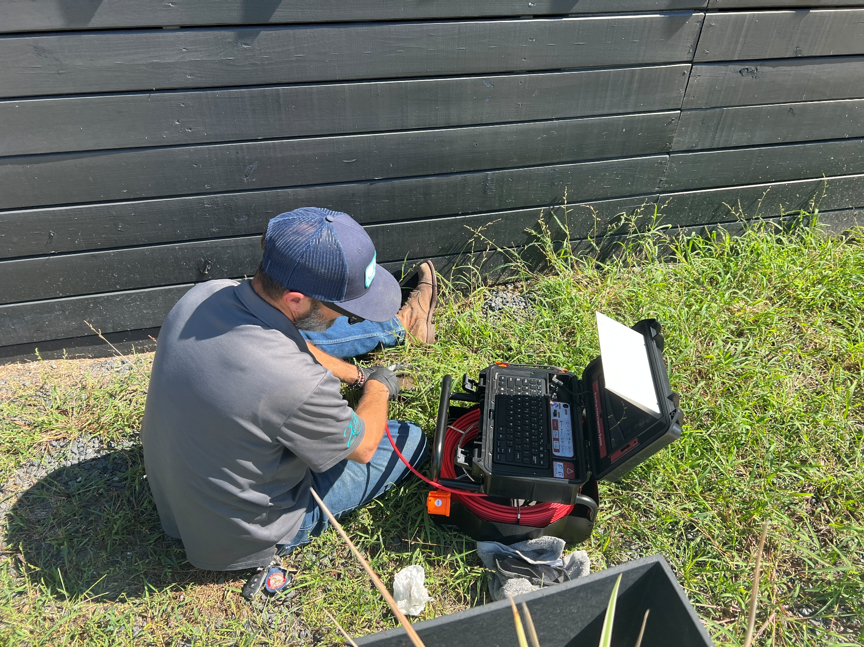
Licensed plumber conducting sewer line inspection.

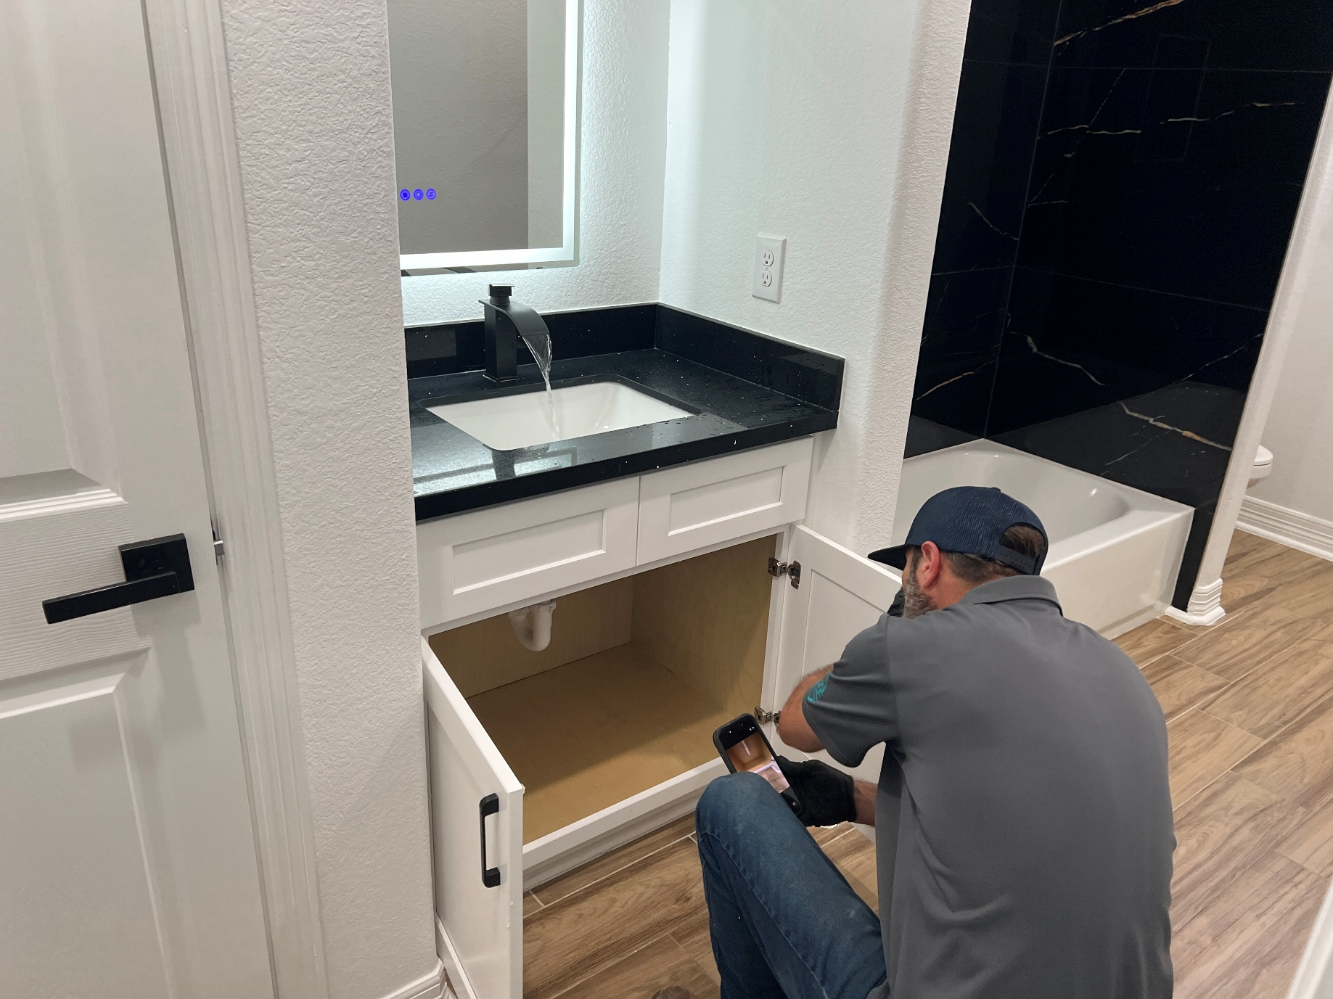
Plumber conducting test of bathroom sink and drain.

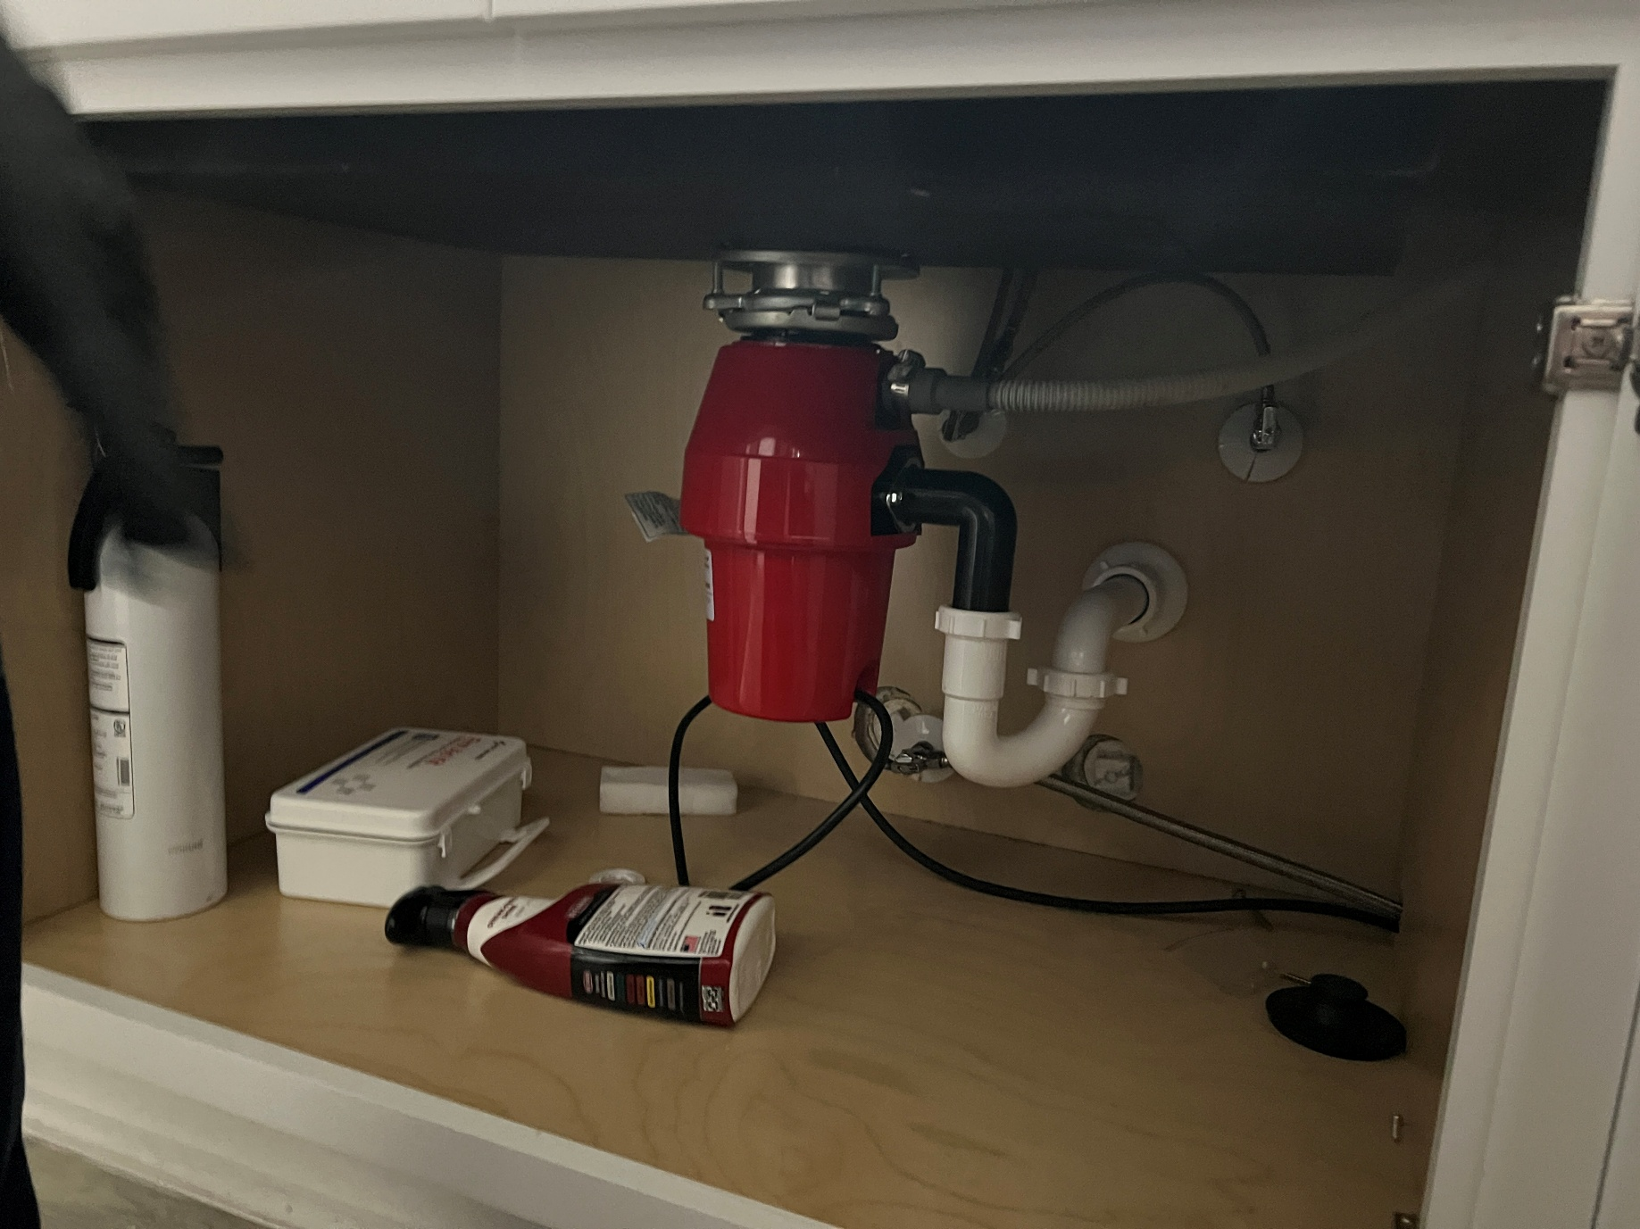
Standard kitchen sink plumbing.

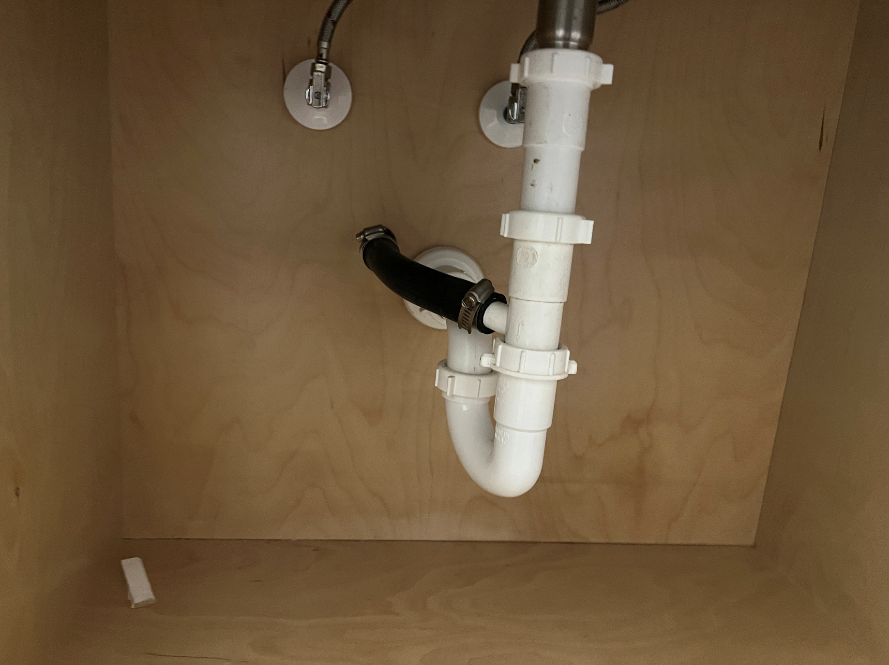
Standard bathroom sink plumbing with AC drain line.

